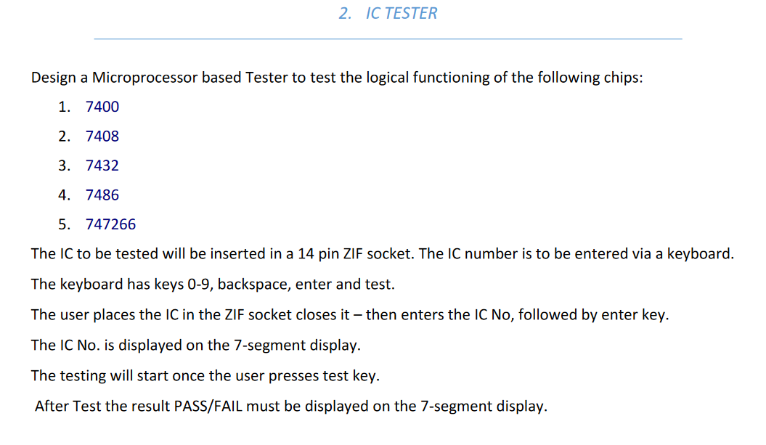

**Gates to test**

7400 - NAND

7408 - AND

7432 - OR

7486 - XOR

747266 - XNOR

**8255s required**

Keyboard - 8 pins - 4 out and 4 in - 8255-1 CL + CU

Seven Segment Display - 8 out (inputs to displays) + 6 out (enables to every display) - 8255a A + B

ZIF socket - 8 in + 4 out - 8255b A(input) + CU(output)

**General Points while coding**

* Have a count of numbers that has been typed.
* Use the count to check if backspace is pressed when count is zero.
* Use the count to check if digit is entered after count is 6.
* Use the count to reduce the number of IC numbers to compare with. (Compare an x digit IC number with only x digit ICs in the database)
* Initially have 0000 as the IC number before a digit is pressed.

**What to ask Anupama**

1. Is there a component for ZIF in proteus? Do we make a make shift ZIF?
2. Where are the ICs in proteus?????
3. What is the pass condition? One IC working? Or all ICs working??

